RiskForge

Contents
Title page 1
Introduction 2
Project objectives 2
Application description 2
requirements 2
Technology stack 3
System architecture 3
Implementation 3
Testing plan 3
Risk and challenges 3
Results and evaluation 3
Legal, ethical and professional considerations 3
Conclusion 3
References/ appendix 3

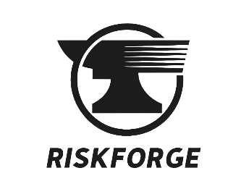
A Cybersecurity Vulnerability Management Platform
CIS2050-N-FJ1-2025 Enterprise Project
BSc Cyber Security
Teesside University
Team Members
Team Member 1 | Database Administrator/Generalist
Daniel Legg | Full Stack Developer
Team Member 3 | Software Tester
Team Member 4 | Backend Developer
Team Member 5 | Server Administrator/Generalist
Team Member 6 | Flexible Support

Introduction

Overview
RiskForge is a cybersecurity vulnerability management platform that provides clear visibility of cyber risk and streamlines vulnerability remediation across an organisation’s infrastructure.
The platform enables users to manage assets, initiate vulnerability scans and automatically convert results into actionable remediation tickets. It integrates industry-standard tools such as GVM/OpenVAS and Nmap alongside AI-assisted analysis to deliver comprehensive vulnerability coverage. Scan data is enriched using a custom RiskForge scoring model, which adjusts severity based on asset criticality and exposure to reflect real-world business impact.

Problem Statement
Modern organisations face significant challenges in managing vulnerabilities across increasingly complex IT environments. Existing vulnerability scanning tools often generate large volumes of raw data without sufficient context, making it difficult for security teams to prioritise remediation efforts effectively.
Many enterprise solutions are complex, costly and require significant expertise to operate, limiting their accessibility for smaller organisations or learning environments. As a result, vulnerabilities may remain unaddressed, increasing the risk of exploitation and negatively impacting overall security posture. This highlights as real need for a solution that not only identifies vulnerabilities but also contextualises risk and streamlines remediation through a more accessible and integrated platform.

Purpose of the PoC
The purpose of this Proof of Concept (PoC) is to demonstrate the viability of an integrated vulnerability management platform that combines asset management, vulnerability scanning and contextual risk prioritisation within a single system. It aims to evaluate whether vulnerability data from multiple sources can be effectively aggregated, processed and transformed into actionable remediation workflows through automated ticket generation. It explores the effectiveness of enhancing traditional CVSS scoring with contextual factors such as asset criticality and exposure to reflect real-world risk.
The system is also used to evaluate the value of incorporating AI-assisted analysis to improve the interpretability of scan results and support decision-making during remediation. Overall, the PoC should demonstrate that a lightweight, web-based platform can provide improvements in vulnerability visibility, prioritisation and remediation management within an enterprise environment.

Research Question
How can an integrated vulnerability management platform improve visibility, prioritisation and remediation of vulnerabilities within enterprise networks?

Aims
- Develop a functional Proof of Concept (PoC) vulnerability management platform that demonstrates the integration of asset management, vulnerability scanning and remediation tracking within a unified system.
- Investigate the effectiveness of contextual risk scoring by enhancing standard CVSS metrics with asset-specific factors such as criticality and exposure.
- Design and implement a secure and modular web-based architecture, supporting authentication, role-based access control and structured data management.
- Explore the use of automation in vulnerability management workflows, including scan execution, findings processing and ticket generation.
- Evaluate the use of AI-assisted analysis in improving the interpretability and usability of vulnerability data for remediation decision-making.

Objectives
- Implement a secure authentication system using hashed password storage and role-based access control to restrict system functionality based on user roles.
- Develop an asset management module allowing users to create, manage and retire assets, including attributes such as IP address, exposure level and business criticality.
- Integrate external vulnerability scanning tools (e.g. OpenVAS and Nmap) to enable automated scanning of assets and retrieval of vulnerability data.
- Design and implement a findings processing pipeline that stores scan results, applies a custom risk scoring model and prioritises vulnerabilities based on contextual risk.
- Develop a ticketing system that automatically generates remediation tickets from prioritised findings and supports lifecycle management (Open, In Progress, Closed).
- Implement audit logging to track user actions and system events, supporting traceability and accountability.
- Integrate AI-assisted analysis to provide additional insights and remediation guidance for identified vulnerabilities.

Target Users
RiskForge is designed for cybersecurity practitioners and IT administrators operating within small to medium-sized enterprise environments. The primary users are security analysts and system administrators responsible for identifying, prioritising and remediating vulnerabilities across organisational infrastructure.
The platform is also suitable for educational use, providing a practical environment for cybersecurity students to understand vulnerability management workflows including asset tracking, scanning, risk assessment and remediation.
By providing a centralised interface and automated processes, RiskForge supports users in maintaining visibility of their security posture and improving the efficiency of vulnerability management activities.

Deliverables
The deliverables of this project include:
Proof of Concept (PoC) Artefact
- A functional web-based vulnerability management platform demonstrating asset management, vulnerability scanning, risk scoring and remediation tracking capabilities.
Technical Report
- A document outlining the system design, implementation, testing, security considerations and evaluation of the PoC.
Artefact Presentation
- A presentation and demonstration showcasing the system core functionality, technical features and industry relevance.
Supporting Evidence
- Supplementary materials including source code, testing evidence, design artefacts and project management documentation.

Application Description
RiskForge is a centralised vulnerability management platform designed to identify, prioritise and manage security vulnerabilities across organisational assets. The system aggregates scan results from multiple tools and transforms them into structured, actionable remediation workflows and features the following:
Authentication & Role-Based Access Control
RiskForge offers a secure user authentication system whereby passwords are hashed and salted before being stored in the database. Role-Based Access Control is achieved with the inclusion of two user roles, administrators and Read-Only Viewers to control access to system functionality. Admin users can manage user accounts, including creation and retirement.
Asset Management
The platform allows administrators to manage assets by defining attributes such as IP address, asset type, business criticality and exposure. This provides the context required for accurate risk assessment.
Vulnerability Scanning Engine
RiskForge integrates multiple security tools including GVM/OpenVAS, Nmap, Nikto, Nuclei and TestSSL to perform comprehensive vulnerability assessments. Scans are executed centrally via the backend, supporting both network and application-level analysis.
Results & Reporting
Scan results are normalised, stored and categorised by severity, allowing users to analyse vulnerabilities and monitor security posture over time through a centralised interface.
Ticketing & Remediation
Identified vulnerabilities are automatically converted into remediation tickets, supporting a structured workflow from detection to resolution. Tickets can be managed through defined lifecycle stages (Open, In Progress, Closed), providing accountability and traceability.
AI-Assisted Analysis
Optional AI-assisted analysis enhances vulnerability data by providing contextual insights, risk explanations and remediation recommendations, improving the usability of scan outputs.
Audit Logging
The system records key user and system actions, including authentication events, asset modifications, scan execution and ticket updates, supporting traceability and monitoring.
User Interface Overview

RiskForge provides a web-based interface accessible via modern browsers, offering a central dashboard for monitoring assets, scan activity and vulnerability metrics, with navigation to core system modules.

High Level Workflow
- User authenticates into the system
- Assets are added or selected
- A vulnerability scan is initiated
- The backend executes scans and processes results
- Findings are stored and displayed within the dashboard
- Vulnerabilities are reviewed and managed through remediation workflows

Functional Requirements
User Story | Function | MoSCoW
As a user, I want to securely log into the system so that I can access authorised functionality. | Authentication | Must Have
As an administrator, I want role-based access control so that user permissions are restricted appropriately. | Access Control | Must Have
As an administrator, I want accounts to be locked after repeated failed login attempts so that brute-force attacks are mitigated. | Security | Should Have
As an administrator, I want to add and manage assets to that systems can be tracked and assessed for vulnerabilities. | Asset Management | Must Have
As an administrator, I want to define asset attributes such as criticality and exposure so that risk can be contextualised. | Asset Management | Must Have
As a user, I want to initiate vulnerability scans on selected assets so that security issues can be identified. | Scanning | Must Have
As a user, I want to select different scan types so that scans can be tailored to requirements. | Scanning | Should Have
As a user, I want to view scan progress and results so that I can monitor scanning activity. | Scan Monitoring | Must Have
As a user, I want vulnerabilities to be automatically identified and stored so that they can be analysed and managed. | Findings Processing | Must Have
As a user, I want vulnerabilities to be prioritised based on contextual risk scoring so that critical issues can be addressed first. | Risk Scoring | Must Have
As a user, I want vulnerabilities to be automatically converted into tickets so that remediation can be tracked effectively. | Ticketing | Must Have
As a user, I want to update ticket statuses so that remediation progress can be managed. | Ticketing | Must Have
As a user, I want to generate AI-based insights for vulnerabilities so that I can better understand risks and remediation steps. | AI Analysis | Should Have
As an administrator, I want system actions to be logged so that user activity can be audited and monitored. | Audit Logging | Must Have
As a user, I want to filter and search assets, scans and tickets so that I can efficiently navigate the system. | Usability | Could Have

Non-Functional Requirements
Requirement | Attributes | Description
Security | Authentication & Access Control | The system must enforce secure authentication using hashed passwords and role-based access control to prevent unauthorised access.
 | Data Protection | All sensitive data must be protected in transit using HTTPS and securely handled within the backend.
 | Input Validation | The system must validate user input to reduce the risk of injection attacks and malformed data.
Performance | Asynchronous Processing | Long-running processes such as vulnerability scans must be handled asynchronously to maintain system responsiveness.
 | Response Time | The system should respond to user actions within an acceptable time frame under normal operating conditions.
Usability | User Interface | The interface should be intuitive and consistent, allowing users to easily navigate assets, scans and tickets.
 | Accessibility | The system should be accessible via modern web browsers without requiring specialised software.
Reliability | Error Handling | The system should handle errors and provide meaningful feedback to users.
 | System Stability | The application should remain stable during unexpected inputs or failures.
Scalability | Modular Architecture | The system should support the addition of new features and integrations without major redesign.
Maintainability | Code Structure | The system should follow a modular design to support efficient maintenance and updates.
Auditability | Logging | The system must record user actions and system events to support monitoring, traceability and security analysis.

Technology Stack
The technology stack used in RiskForge is detailed below, highlighting the key components and the role within the system.
Category | Technology | Purpose
Backend | Python (Flask) | Provides application logic, authentication and scan orchestration
 | REST API | Enables client-server communication using HTTP methods
Frontend | HTML/CSS | Provides the user interface and layout
 | Jinja2 | Support server-side rending of dynamic content
Database | MariaDB | Stores users, assets, scan results, vulnerabilities and tickets
Communication | HTTPS | Secures communication between system components and external APIs
 | SQL | Enables interaction between backend and database
 | SSH | Allows secure communication with the external scanner host
 | GMP (TCP 9390) | Enables communication with OpenVAS for vulnerability scanning
AI Integration | Groq API | Provides AI-assisted analysis and remediation insights
Security | bcrypt | Ensures secure password hashing
 | RBAC | Restricts system access based on user roles
Scanning Tools | OpenVAS (GVM) | Primary vulnerability scanning engine
 | Nmap | Network discovery and port scanning
 | Nikto | Web server vulnerability scanning
 | Nuclei | Template-based vulnerability detection
 | TestSSL.sh | SSL/TLS configuration analysis
 | Gobuster | Directory and file enumeration
 | SQLMap | Automated SQL injection testing
 | Enum4linux | SMB enumeration
Development Tools | Visual Studio Code | Primary development environment
 | GitHub | Version control and collaboration
 | Trello | Task management and agile workflow tracking
 | Microsoft Teams | Team communication
 | OneDrive | Centralised file sharing
 | Virtual Machines | Controlled testing environment
 | XAMPP | Local database and development stack

System Architecture
RiskForge follows a modular, client-server architecture designed to support scalable vulnerability scanning and asset management. The system separates presentation, application logic, data storage and external integrations to ensure maintainability, security and extensibility.
The frontend interface communicates with a backend API responsible for processing requests and orchestrating scanning operations, whilst a relational database provides persistent storage. External systems are integrated to perform specialised vulnerability scanning and analysis.
This architecture was selected to provide a clear separation of concerns, allowing individual components to operate independently whilst supporting future expansion. It also enables resource intensive scanning tasks to be isolated from the main application, improving overall system performance and security.
The overall system structure is illustrated in Figure 1.
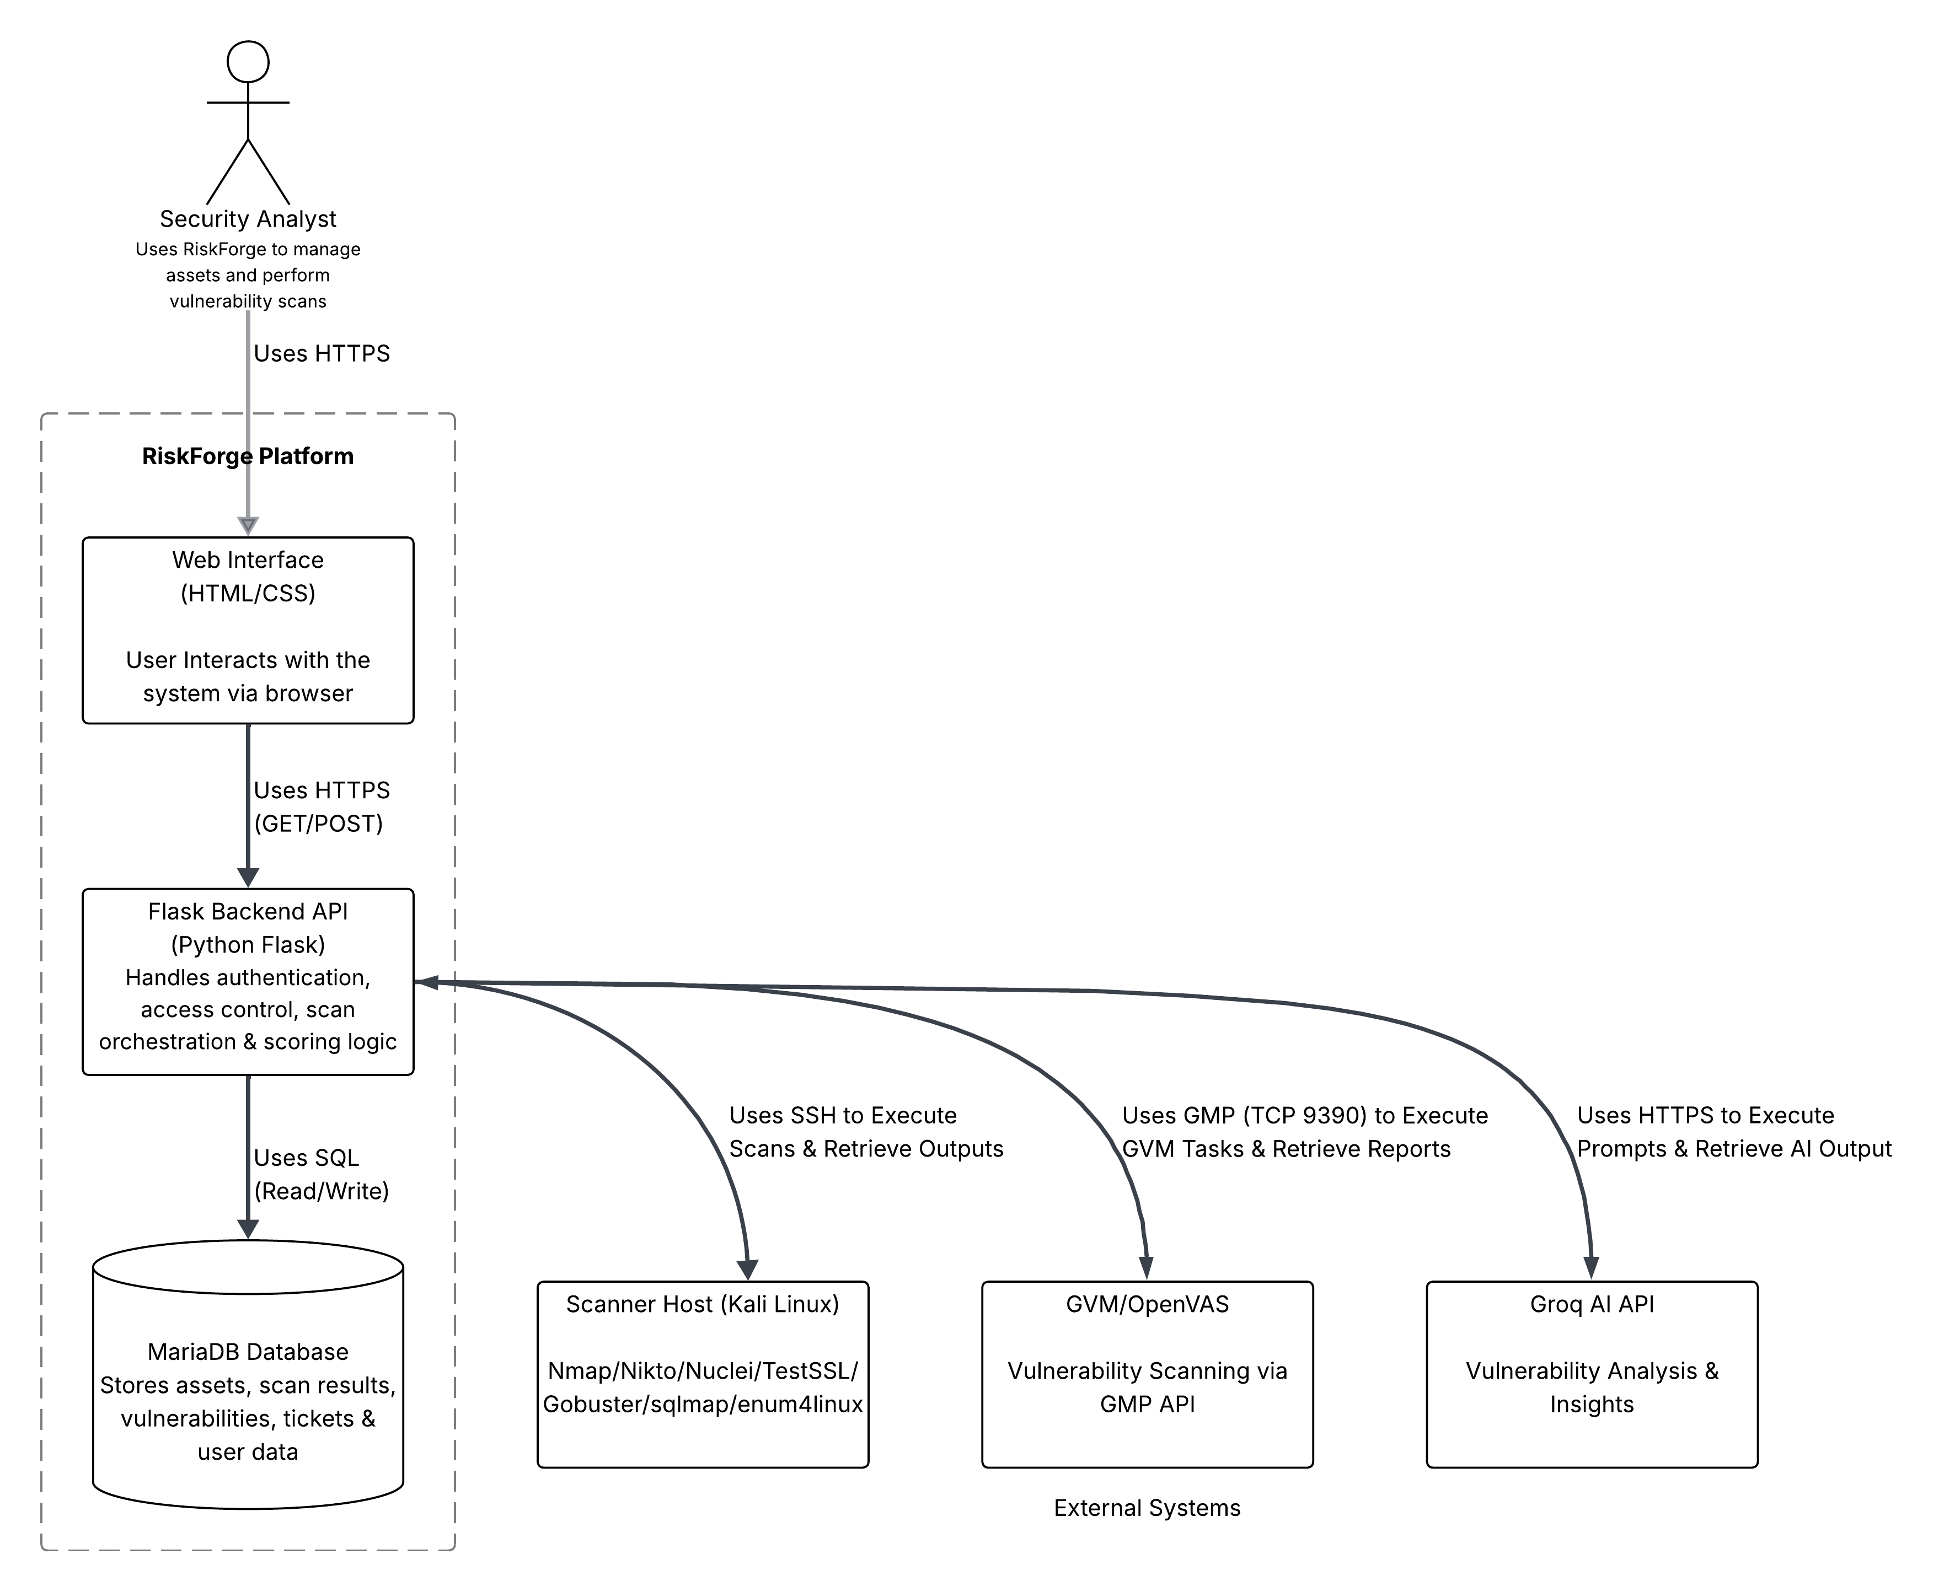
Key Components
- Web Application: Provides a browser-based interface over HTTPS
- Backend API (Flask): Handles authentication, business logic and scan orchestration
- Database (MariaDB): Stores users, assets, scan results and vulnerabilities
- Scanner Host: Executes external security tools and returns results
- OpenVAS: Performs vulnerability scanning via GMP
- Groq API: Provides AI-based analysis of scan outputs
Figure 1: C4 Container Diagram of the RiskForge Architecture

Implementation
The implementation phase focused on developing a functional version of RiskForge based on the defined requirements and system design, in order to demonstrate a proof-of-concept vulnerability management platform. Development followed a client-server model, establishing a clear separation between the frontend (user interaction), backend (application logic), database (persistent storage) and external tools used for scanning and result analysis.

Backend Implementation
The backend acts as the central coordination layer of the system, linking frontend requests, database operations and external scanning tools to enable end-to-end workflows. It processes HTTP GET and POST requests, applies business logic and ensures that operations are executed in the correct sequence before returning responses to the user interface.

Structure & Design
The backend was developed using Flask, chosen for its lightweight and flexible nature, making it well-suited to rapid PoC development whilst supporting future scalability. A modular architecture was adopted rather than a monolithic design, separating the application into routes (request handling), services (business logic) and a database layer (data persistence) (see Appendix C1).
This separation of concerns improves maintainability, readability and extensibility, allowing individual components to be modified or extended without impacting the wider system.

Route Organisation
Application routes are organised into separate modules within the /routes directory, each corresponding to a specific system feature such as authentication, assets, scans and tickets (see Appendix C2). This structure ensures a clear mapping between application functionality and request handling logic, improving code organisation and scalability.

Request Handling & API Design
The backend follows a REST-style structure, using standard HTTP methods such as GET for data retrieval and POST for data submission (see Appendix C3). The frontend interacts with the backend through form submissions and page requests, with responses returned as rendered Jinja2 templates. This ensures a consistent and structured flow between user actions and system responses.

Service Layer
Core application logic is implemented within service modules located in the /services directory, preventing routes from becoming overly complex and reinforcing separation of concerns (see Appendix C4).
The service layer acts as an intermediary between the routes, database and external integrations, handling workflows such as scan execution, results processing and ticket creation. For example, GVM scan initiation, progress monitoring and results parsing are contained within dedicated service functions (see Appendix C5).
This approach results in a cleaner architecture and supports easier maintenance, testing and future expansion.

Authentication & Access Control
User authentication is implemented using a session-based approach supported by Flask’s session object. User credentials are validated against stored records, with passwords securely hashed using bcrypt before comparison.
Upon successful authentication, a session cookie is created containing key user information such as user ID and role (see Appendix C6). This session data is used to enforce role-based access control across the application, restricting functionality based on user permissions (see Appendix C7).
The session cookie is cryptographically signed using a secret key stored in environment variables in order to prevent tampering and enhance security.

Database Interaction
MariaDB is used as the relational database for storing all persistent application data. The backend interacts with the database through dedicated functions within the db.py module (see Appendix C8), supporting operations such as data insertion, retrieval and updates.
Parameterized SQL queries are used to mitigate SQL injection risks (see Appendix C10), whilst the database schema is structured around key entities including users, assets, scans, findings and tickets (see Appendix C9). This ensures consistent and structured data management across the application.

Error Handling
The backend includes validation and error handling mechanisms to manage invalid input, unauthorised access and unexpected system behaviour. User input is validated within route handlers, with feedback provided through error messages or redirection where appropriate.
Access control is enforced through session validation, with unauthenticated users redirected to the login page and unauthorised actions resulting in a 403 error. Additional custom error pages (403, 404 and 500) are implemented to handle common failures (see Appendix C11).

Audit Logging
Audit logging was implemented to provide traceability and accountability across system operations. Key events such as authentication attempts, asset modifications, scan execution and ticket updates are recorded within a central audit log.
Logging is handled through a dedicated function within the service layer, ensuring consistent usage across both request-based and background operations (see Appendix C12). This supports system monitoring, debugging and security oversight. Audit logs are accessible via the application interface, allowing administrators to review and filter system activity as required.

Scanner Integration
RiskForge integrates multiple external security tools to perform vulnerability scanning. Rather than executing scans directly within the web application, scanning is delegated to external modules hosted on a separate Kali Linux machine for the proof-of-concept. The backend is responsible for triggering scans, coordinating execution and processing results, providing a centralised and automated workflow compared to manual tool usage. This approach improves scalability, security and maintainability by isolating scanning operations from the main application.

Scan Triggering
Scans are initiated via the frontend by selecting a target asset and scan type (e.g. GVM, AI or Full Scan) (see Appendix D1). The request is handled by the backend, where input validation is performed and the appropriate scan configuration is determined.
A corresponding scan record is created within the database, linking the scan instance to the selected asset and enabling progress tracking throughout execution.

Scan Execution
Scan execution is performed externally on a dedicated Kali Linux host, ensuring that resource-intensive operations do not impact the performance of the web application. This design also enhances security by isolating scanning tools within a controlled environment.
The backend communicates with the scanner host over SSH using the Paramiko library, enabling secure remote command execution (see Appendix D2). Multiple tools are integrated including Nmap, Nikto, Nuclei, TestSSL, Gobuster, SQLMap and Enum4Linux.
Conditional execution is applied to improve efficiency, ensuring that tools are only run when relevant services are detected (e.g. web-based tools executed only when HTTP/HTTPS services are present).
During execution, scan output is captured in real time and stored in the database, allowing users to monitor progress and view live results through the interface (see Appendix D3).

Execution Workflow
- Backend passes Target IP address and scan type
- Scanner executes selected tools and manages execution flow
- Backend monitors progress, either synchronously or via a background worker
This workflow enables RiskForge to centrally manage complex scanning processes whilst maintaining flexibility for future expansion.

Result Processing & Storage
Following execution, scan results are returned as both real-time output and structured JSON data for further processing. The scanner performs initial normalisation of findings, ensuring a consistent schema across different tools and data sources.
The backend extracts structured findings from the output and processes them before storing them in the database. A marker string is used to distinguish structured results from raw output, enabling reliable parsing and separation of monitoring data from processed findings.
A custom RiskForge scoring model is applied to each finding, incorporating factors such as CVSS score, asset criticality and exposure. This enhances raw vulnerability data with contextual risk prioritisation.
Processed findings are stored and categorised by severity, before being used to automatically generate remediation tickets (see Appendix D4). This supports a complete workflow from vulnerability detection through to remediation tracking.
Audit log entries are generated at each stage of the process, ensuring traceability of scan execution, findings processing and ticket creation.

OpenVAS Integration
OpenVAS (Greenbone Vulnerability Management) is implemented as the primary vulnerability scanning engine within RiskForge, providing structured vulnerability data, CVSS-based scoring and vulnerability definitions (NVTs). It acts as the authoritative source of vulnerability data within the system, ensuring consistent and reliable detection or analysis and reporting.
The backend communicates with OpenVAS using the Greenbone Management Protocol (GMP) over a secure TLS connection, with authentication handled through GVM credentials. Scan tasks are created dynamically based on the selected asset, with unique identifiers returned to enable tracking of scan progress and retrieval of results.
Due to the potentially long runtime of vulnerability scans, execution is handled asynchronously to prevent blocking the web application. A background worker monitors scan progress at regular intervals, updating status and progress within the database.
Once complete, the scan report is retrieved in XML format and processed to extract key vulnerability data, including NVT name, port, CVSS score, CVEs and recommended remediation. The results are normalised into a structured format before being passed into the main processing pipeline for storage, prioritisation and ticket generation.
Overall, the integration of OpenVAS provides RiskForge with industry-standard vulnerability scanning capabilities, forming a reliable foundation for consistent vulnerability analysis and remediation workflows.

AI Integration
RiskForge integrates an external AI service to enhance vulnerability evaluation and remediation. The AI component acts as an analytical layer rather than a scanning mechanism, enriching raw scan data with contextual insights and remediation guidance.
AI analysis is performed automatically during selected scan types (Full Scan and AI Scan), generating structured findings and executive summaries. Additionally, it is used within the ticketing system to provide on-demand analysis of individual vulnerabilities, supporting more informed remediation decisions.
AI functionality is implemented using the Groq API, with communication handled via secure HTTPS requests (see Appendix E1). Authentication is managed by an API key stored in environment variables, following secure configuration practices. The selected model (llama-3.1-8b-instant) was chosen due to its low latency, cost efficiency and ability to generate structured, context-aware responses suitable for near real-time analysis (Groq, 2026).

AI Integration within Scanning
Within the scanning workflow, AI is used to enhance and standardise raw outputs generated by integrated tools. It assists in extracting structured findings, generating per-vulnerability analysis and producing an overall executive summary of the scan.
This improves the usability of raw scan data by providing clearer risk insights, impact context and actionable remediation recommendations, which are returned to the main application as part of the structured scan output.

AI Integration within Ticketing System
AI analysis can also be triggered manually from within the ticketing interface (see Appendix E2). When invoked, relevant ticket data is processed and sent to the AI service, with the resulting analysis stored and displayed alongside the ticket (see Appendix E3).
The output includes enhanced vulnerability descriptions, potential impact and recommended remediation steps, supporting users in prioritising and resolving issues more effectively.
Structured prompts are used to guide AI responses, ensuring consistency, clarity and practical outputs while reducing the likelihood of vague or generic responses (see Appendix E4).
Access to AI functionality is controlled through role-based access control, restricting usage to authorised users at both the frontend and backend levels.

Testing Plan

Testing strategy
The focus of the testing strategy for this project was validating the functionality of the vulnerability management system. This was conducted using manual, functional and end-to-end workflow. Manual testing was able to help ensure the system performed as intended from a user perspective. Functional testing helped verify that system components met requirements for operations. Finally end-to-end was able to simulate real user workflows, including logging in/out, adding assets and running scans on said asset. Also, as well as viewing and managing ticket data.
Testing was conducted throughout the entire development to help identify and remedy defects and make sure core functions such as authentication, scanning and ticket management were all operational.

Test Case design
The test cases were designed and based upon validating functional requirements and to ensure correct behaviour during normal and error conditions. These tests were based on key system features including asset management, ticket handling and scanning.
Positive and negative testing approaches were both conducted. Positive test help to ensure correct system behaviour provided they are given valid inputs. Negative testing helped verify how the system would handle invalid inputs and/or incorrect actions and display appropriate error handling response.
These test cases were also structured around realistic user workflows instead of it being treated as separate individual functions. For example the process of adding an asset, running a scan, ticket creation and viewing the tickets were tested as a complete sequence. This helps to ensure that system functions can properly interact with one another.

Example test cases
ID | Description | Steps | Expected Result | Actual Result | Result | Comments
T-1 | Valid login | Enter valid credentials | Redirect to dashboard | As expected | Pass | Authentication works
T-2 | Invalid login | Enter wrong password | Error message shown | As expected | Pass | Handles failure
T-3 | Add asset | Input asset details | Asset saved | As expected | Pass | Works correctly
T-4 | Start scan | Select asset and scan | Scan starts | As expected | Pass | Workflow correct
T-5 | View findings | Open scan results | Vulnerabilities shown | As expected | Pass | Data displayed

Test coverage
The testing coverage extended to key functional and vital areas of the system to help ensure that it operated correctly and was able to meet all expectations and requirements. One key system included authentication. This included successful and failed login attempts with correct error handling message in the event of failed login. Asset management included adding new assets, editing existing assets and retiring old ones. Testing coverage also included vulnerability scanning. It was tested to make sure that scans could be initiated and their progress monitored during said scans.
Testing was also done to cover the processing of scan findings. This included viewing how vulnerabilities are catalogued and displayed for user viewing. The ticket lifecycle was tested to ensure that tickets can be properly created and closed when a security issue has been resolved.

Testing tools and environment
Testing was conducted using manual tools in conjunction with a controlled development environment. The system was tested through a web browser to help simulate real user interaction and validate functionality
Application was developed locally using Flask and MariaDB, this allowed for efficient testing and debugging during development. Virtual machines such as metasploitable were used to simulate vulnerable targets for scanning and testing purposes. External tools such as OpenVAS and Nmap were utilised to perform vulnerability scanning and generate realistic findings for the system.

Test evidence
Additional test cases and supporting evidence including the full testing documentation is included with the materials in the supplementary zip file with this project.

Limitations of testing
Testing was conducted across the main system features however there were some limitations present. Testing was majority manual testing with limited usage of automated testing being conducted. Some areas such as role-based access control and AI output consistency were not tested in full depth. Additionally, no formal penetration testing was conducted asynchronous processes such as scanning were difficult to fully validate.

Risks & Challenges

Security Risks
There was multiple security risks identified during the development and deployment of the PoC. Firstly, the absence of CSRF protection introduces the risk of unauthorised requests being executed through forged POST actions. During testing, an XSS vulnerability was identified within HTML templates, exposing the system to potential client-side script injection if user inputs are not properly escaped.
The authentication system lacks advanced security controls such as multi-factor authentication (MFA) and session expiry policies. As a result, authentication relies solely on session-based mechanisms, which may be insufficient in a production environment. The use of a self-signed SSL certificate ensures that encryption is present for demonstration purposes but would not be trusted in a production environment.
Although role-based access control is enforced within the backend, it is essential that all privileged actions are consistently validated across all routes prior to production deployment in order to reduce the risk of privilege escalation. The use of SSH-based communication with the external scanner host introduces additional risk in relation to credential management and trust within the network environment.

Technical Challenges
During development, multiple technical challenges were encountered and required resolution. The integration of multiple external tools such as OpenVAS, Nmap and Nuclei presented a challenge due to different output formats needing to be normalised into a consistent schema for processing. Managing real-time scan output streaming to the web interface whilst maintaining application responsiveness, coordinating scan execution across multiple tools and achieving stable and reliable communication between the backend and the remote scanner host over SSH all required careful design and handling.

AI Integration Challenges
During AI integration, multiple challenges were presented such as ensuring the consistency and relevance of AI-generated outputs across different vulnerability types. Without carefully structured prompts, there is a risk of generating generic or non-actionable responses. AI functionality is dependent on external API availability and latency which is outside of the administrator’s control. There is difficulty in validating the accuracy and reliability of AI-generated remediation advice, highlighting the need to balance the usefulness of AI insights with the risk of misleading or incomplete remediation suggestions.

Data & Processing Challenges
Due to the large volumes of data generated by vulnerability scanning tools, it was challenging to handle and process this data efficiently without degrading system performance. This was addressed through the use of asynchronous background workers to manage long-running scan operations.
A relational database schema was designed to handle complex relationships between assets, scans, findings and tickets. Ensuring data consistency during concurrent operations, such as scans updating while users interact with the system also presented a challenge during development.
A custom risk scoring model was implemented to enhance standard CVSS scoring with contextual factors, whilst avoiding oversimplification of vulnerability severity. Managing the storage and retrieval of real-time scan output alongside structured findings required careful design to balance performance and usability. Overall, these challenges highlight the complexity of handling large amounts of vulnerability data whilst maintaining performance, consistency and usability within the web-based system.

Results and Evaluation

1. Overview of Results
Developing RiskForge resulted in a functional Proof of Concept (PoC) cybersecurity vulnerability management platform that showed the practicality of merging multiple security features into a single system. Our platform was able to support services from scan initiation to findings processing and ticket generation.
Testing confirmed that the end-to-end process of asset selection → vulnerability scan → findings storage → prioritisation → remediation ticket creation operated successfully. Integrating services such as OpenVAS, Nmap and AI-assisted analysis was also accomplished. This proves that a lightweight web-based platforms [HTML] can house vulnerability management tasks that would otherwise require multiple disconnected tools.
Although the system is not production-ready, the PoC successfully validated the overall concept and showed clear potential for further development.

2. Evaluation Against Objectives

Objective 1 – Secure Authentication System
- Secure login functionality was successfully implemented.
- Passwords were hashed using bcrypt before storage.
- Role-Based Access Control (RBAC) restricted features based on user roles.
- Account lockout after repeated failed attempts was implemented.
- However, a limitation is that Multi-Factor Authentication (MFA) and CSRF protection were not implemented. These would be essential in a production environment.

Objective 2 – Asset Management Module
- Full CRUD functionality (Create, Read, Update, Delete) was implemented for asset records.
- Assets stored contextual attributes such as IP address, exposure level and business criticality.
- Duplicate asset prevention was included.
- This provided the data needed for contextual risk scoring.
- However, a limitation is the lack of bulk asset import, automated discovery or API synchronisation with enterprise asset inventories.

Objective 3 – Vulnerability Scanning Integration
- OpenVAS integration was functional and successfully returned structured vulnerability data.
- Additional tools such as Nmap, Nikto, Nuclei and TestSSL were integrated into the scanning workflow.
- Remote execution over SSH worked reliably during testing.
- This demonstrates successful orchestration of multiple external tools through one interface.
- However, a limitation is dependency on the external scanner host. If the remote host is unavailable, scanning functionality is affected.

Objective 4 – Findings Processing and Risk Prioritisation
- The custom RiskForge scoring model was successfully applied to findings.
- It combined CVSS severity with asset criticality and exposure level.
- This improved prioritisation compared with raw scanner output alone.
- For example, externally exposed critical systems were ranked higher than lower-value internal assets.

Objective 5 – Ticketing System
- Vulnerabilities were automatically converted into remediation tickets.
- Ticket lifecycle stages (Open, In Progress, Closed) were implemented successfully.
- The workflow reduced manual administrative effort.
- However, a limitation is the absence of SLA timers, ownership assignment and escalation workflows.

Objective 6 – Audit Logging
- Key user and system events were logged successfully.
- Logging covered authentication activity, asset changes, scan actions and ticket updates.
- Logging worked across both normal routes and background tasks.
- This demonstrates improved traceability and accountability.
- However, audit log integrity and long-term retention controls were not formally tested.

Objective 7 – AI-Assisted Analysis
- AI-generated insights were successfully integrated using the Groq API.
- The system produced summaries, risk explanations and remediation suggestions.
- This improved the usability of raw technical scan results.
- AI functionality was particularly useful for translating technical findings into actionable language.
- However, output consistency varied depending on prompt quality, meaning human review is still required.

3. System Strengths
- Strong separation of concerns through modular backend architecture.
- Successful integration of multiple industry security tools.
- End-to-end automated workflow from detection to remediation.
- Contextual risk scoring improves decision-making over raw CVSS values.
- Centralised web interface improves visibility of assets and findings.
- Real-time scan monitoring improves user awareness during long-running scans.

4. Limitations and Weaknesses
- CSRF protection was not implemented.
- XSS vulnerability was identified during testing.
- Reliance on an external scanner host creates a single point of dependency.
- AI-generated recommendations cannot be guaranteed accurate.
- Self-signed SSL certificate is not suitable for production deployment.
- Some user interface areas lacked polish and consistency.
- Scalability under enterprise-scale workloads was not fully tested.

Overall, RiskForge successfully met its primary objective of demonstrating an integrated vulnerability management platform. The PoC showed that asset management, vulnerability scanning can be combined into one unified solution.
This demonstrates clear improvement over traditional raw scan outputs by adding business context, workflow automation and usability enhancements. The system is not yet production-ready due to security, scalability and testing limitations. However, it provides a strong prototype.
With further hardening, expanded reporting and stronger automation, RiskForge could evolve into a practical vulnerability management solution for real organisational environments.

Legal, ethical and professional considerations
Due to handling large volumes of sensitive data from many third-party companies, Risk Forge has many legal, ethical and professional considerations.
To satisfy professional considerations, and conduct business to a high standard, Risk Forge will comply with the British Computer Society Code of Conduct. This will ensure high service to clients. below are standard to follow from the code of conduct.
Public interest
- have due regard for public health, privacy, security and wellbeing of others and the environment.
- have due regard for the legitimate rights of Third Parties.
- conduct your professional activities without discrimination on the grounds of sex, sexual orientation, marital status, nationality, colour, race, ethnic origin, religion, age or disability, or of any other condition or requirement.
- promote equal access to the benefits of IT and seek to promote the inclusion of all sectors in society wherever opportunities arise.
Professional competence and integrity
- only undertake to do work or provide a service that is within your professional competence.
- NOT claim any level of competence that you do not possess.
- develop your professional knowledge, skills and competence on a continuing basis, maintaining awareness of technological developments, procedures, and standards that are relevant to your field.
- ensure that you have the knowledge and understanding of Legislation* and that you comply with such Legislation, in carrying out your professional responsibilities.
- respect and value alternative viewpoints and, seek, accept and offer honest criticisms of work.
- avoid injuring others, their property, reputation, or employment by false or malicious or negligent action or inaction.
- reject and will not make any offer of bribery or unethical inducement.
Duty to relevant authority
- carry out your professional responsibilities with due care and diligence in accordance with the Relevant Authority’s requirements whilst always exercising your professional judgement.
- seek to avoid any situation that may give rise to a conflict of interest between you and your Relevant Authority.
- accept professional responsibility for your work and for the work of colleagues who are defined in each context as working under your supervision.
- NOT disclose or authorise to be disclosed, or use for personal gain, or to benefit a third party, confidential information except with the permission of your Relevant
- Trustee Board Regulations Schedule 3 v8 Code of Conduct for BCS Members Page 3 of 5 Reviewed by Trustee Board 8 June 2022
- Authority, or as required by Legislation.
- NOT misrepresent or withhold information on the performance of products systems or services (unless lawfully bound by a duty of confidentiality not to disclose such information) or take advantage of the lack of relevant knowledge or inexperience of others.
Duty to the profession
- accept your personal duty to uphold the reputation of the profession and not take any action which could bring the profession into disrepute.
- seek to improve professional standards through participation in their development, use and enforcement.
- uphold the reputation and good standing of BCS, the Chartered Institute for IT.
- act with integrity and respect in your professional relationships with all members of BCS and with members of other professions with whom you work in a professional capacity.
- encourage and support fellow members in their professional development.
By following the above protocols, Risk Forge will easily comply with legislations regarding privacy and security, but an outline of laws set by the UK government will be discussed below.

To ensure data privacy and protection, Risk Forge will comply to the Cyber Governance Code Of Practice, OWASP guide for access control, Information commissioners’ office and ISO standard for security management systems. Adherence to the GDPR (General Data Protection Regulation 2018) is also vital to follow, especially when dealing with third-party companies in a high volume. Risk Forge must also ensure the clients they take on have a sufficient competence and jurisdiction with data protection legislations, to help protect themselves from indirect involvement of malpractice.
- Data encryption- data in transit will be sent using asymmetric encryption to ensure security and integrity when in transit. All passwords will be stored in hash formats along with the use of SALTS
- Role-based access and multi-factor authentication will be used to limit access to sensitive data
- Data minimisation- only required data from third party companies will be used.
- Data retention- data will not be kept longer than needed
- Secure storage- stored information will be kept in secure facilities, and encrypted
- Data integrity and audits- all data will have a high standard of integrity with the use of SALTS and regular security, and performance audits will be carried out against the organisation to ensure compliance.
Data encryption
Role-based access | Only selected user roles will be able to access certain features e.g only i.t admins will be able to access scan contents, but anyone can initiate them.
Data minimisation | Only required data from third party companies will be required. Minimal data about assets
Data retention | All data will be kept for a minimum of 1 year to ensure strong integrity for audits.
Secure storage
Data integrity and audits | Audits will be regularly carried out against riskforge to ensure all regulations are being met. Audits against third party companies will be required to ensure they meet the criteria for riskforge to ensure the highest level of service.

To maintain a good public image, Risk Forge should inform clients of all processing’s of their data. Any mistakes that result in a lack of data security or data breach should be reported to the relevant authority as soon as possible

(BCS, 2022)

Conclusion

During the project, a platform for vulnerability detection and management was successfully developed and tested. The work, the team managed to combine different types of software to create the desired product.

The main achievements that have been achieved

• Developed a comprehensive workflow, from scan initiation to automatic ticket generation based on vulnerabilities

• Successfully integrated industry scanning tools such as OpenVAS, Nmap, and others

• Implemented a robust authentication and access control system based on RBAC roles

• Implemented a custom RiskForge scoring model, enabling context-sensitive risk assessment

• Integrated AI functionality to provide threat remediation recommendations

Testing and evaluation results demonstrated that all key project objectives were achieved. The system fully confirmed its technical feasibility. RiskForge demonstrates significant advantages over raw scan data from other software.
Limitations
Despite the successful implementation, the current version has certain limitations.
- The system is a prototype (PoC) and is not currently ready for industrial use.
- Security gaps in the web interface were identified, such as susceptibility to CSRF and XSS attacks
- The system remains highly dependent on the configuration of external tools and third-party libraries
- There is no redundancy in the projects because all the software runs on the university's virtual machine.
Future Work
- Carrying out work to strengthen security, including the implementation of protection against CSRF
- further development of the risk assessment model
- expanding AI analytics capabilities and introducing detailed reporting features
Final Statement
The developed RiskForge system provides a solid foundation for vulnerability management and demonstrates high applicability in real-world cybersecurity scenarios. The project has significant potential for further scaling and development into a full-fledged enterprise solution.

References
BCS (2022). CODE OF CONDUCT FOR BCS MEMBERS. [online] Available at: https://www.bcs.org/media/2211/bcs-code-of-conduct.pdf.

Appendix

Appendix A – Trello Board Evidence
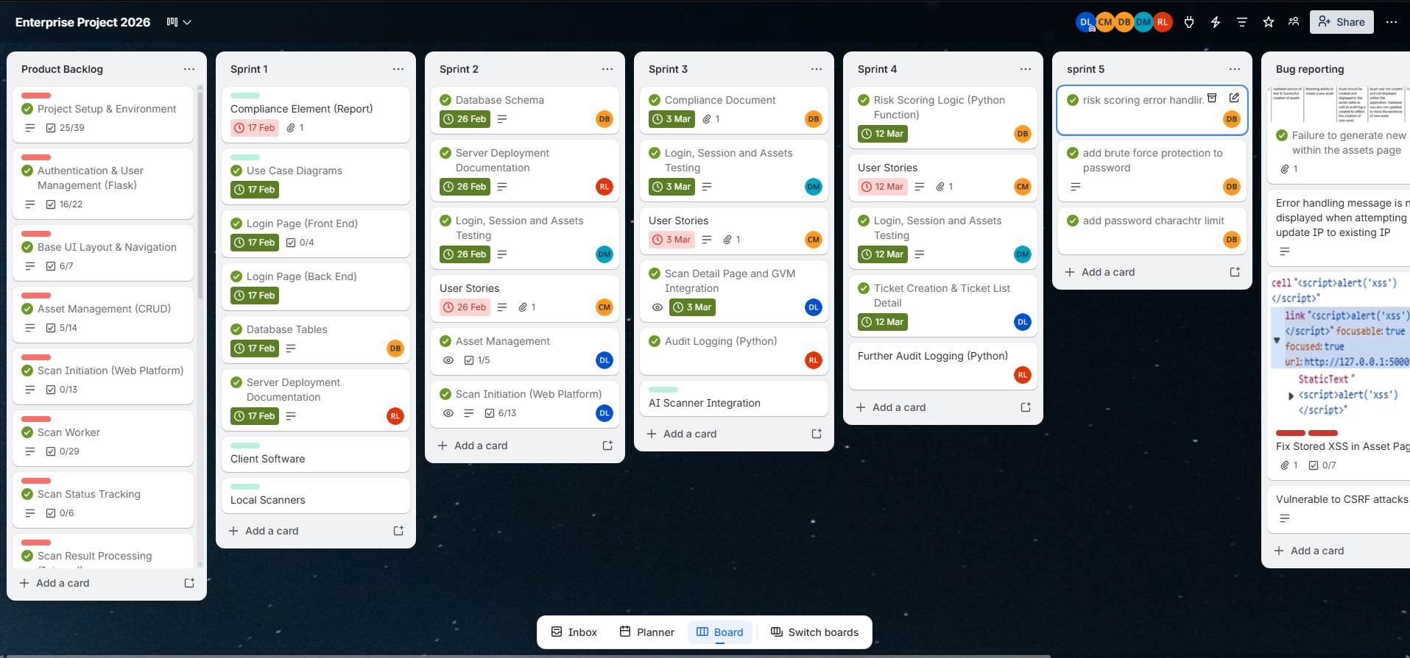
Figure A1 – Trello Board showing product backlog and task progression

Appendix B – GitHub Collaboration Evidence
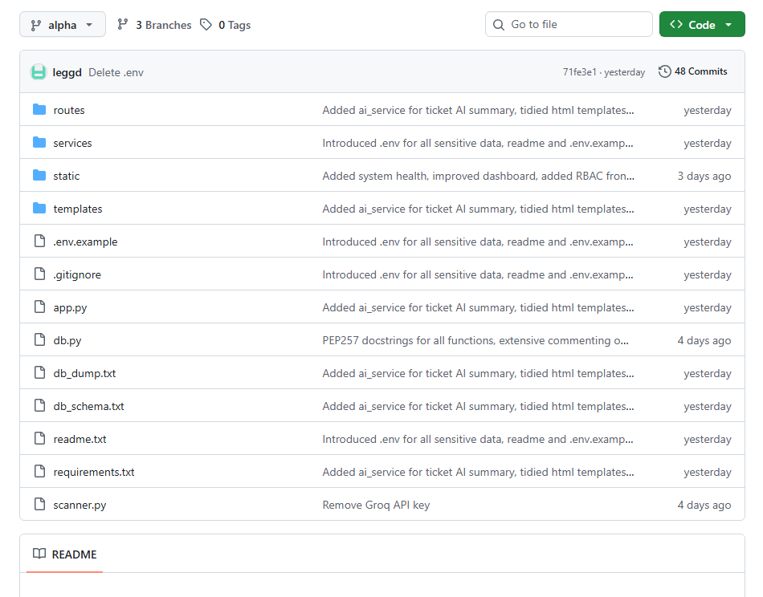
Figure B1 – GitHub Repository File Listing
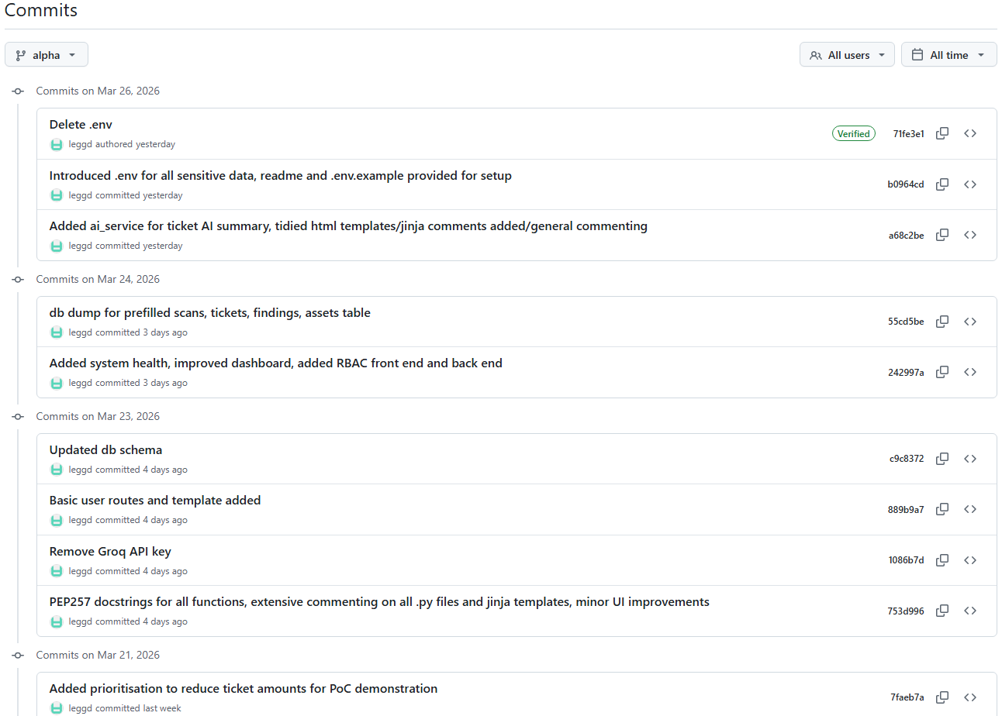
Figure B2 – GitHub Commits Sample

Appendix C – Backend Implementation Evidence
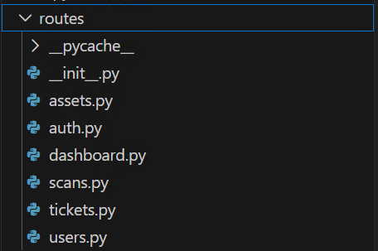
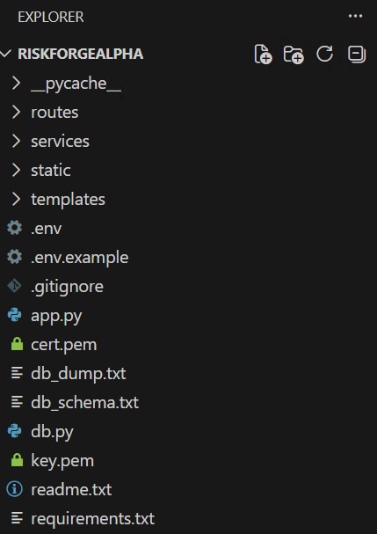
Figure C1 – Project Folder Structure Figure C2 – Route Module Separation
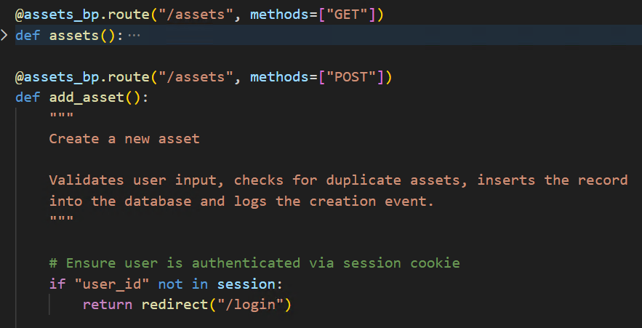
Figure C3 - Flask route demonstrating GET and POST request handling
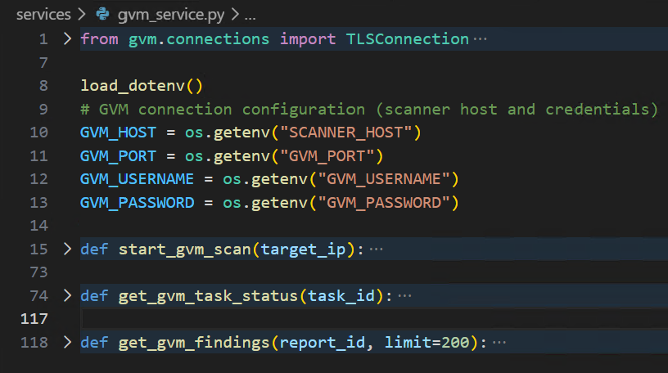
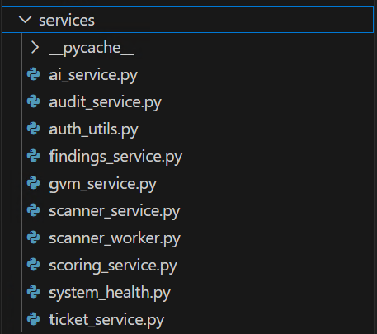
Figure C4 – Service Modules Figure C5 – gvm_service.py overview
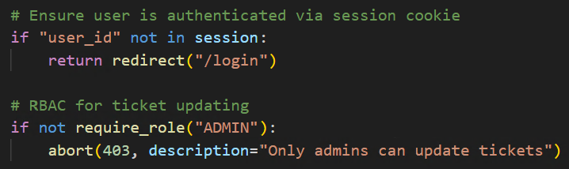
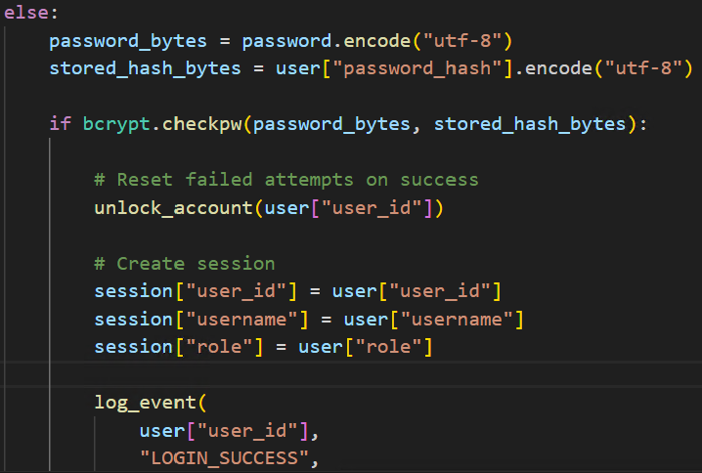
Figure C6 – Password Validation & Figure C7 – Authentication and RBAC sample usage
Session Creation from auth.py/login() from tickets.py/update_ticket()
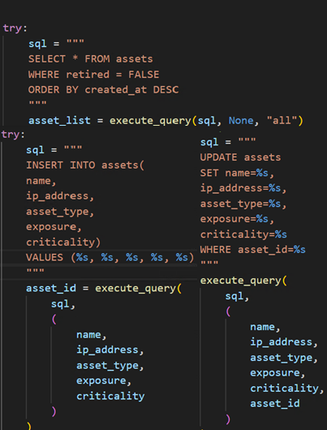
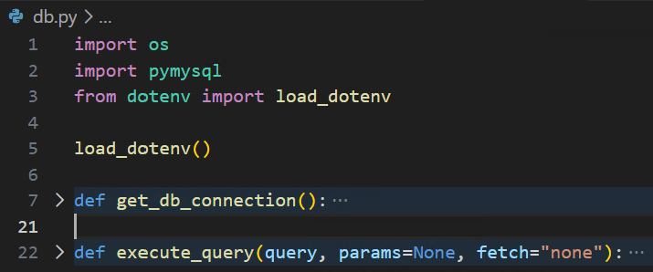
Figure C8 – Database Interaction Functions
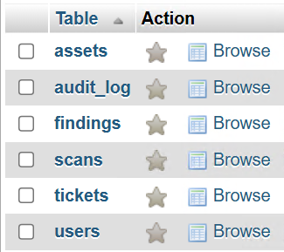
Figure C9 – Database Tables Figure C10 – Sample SELECT, INSERT and UPDATE queries
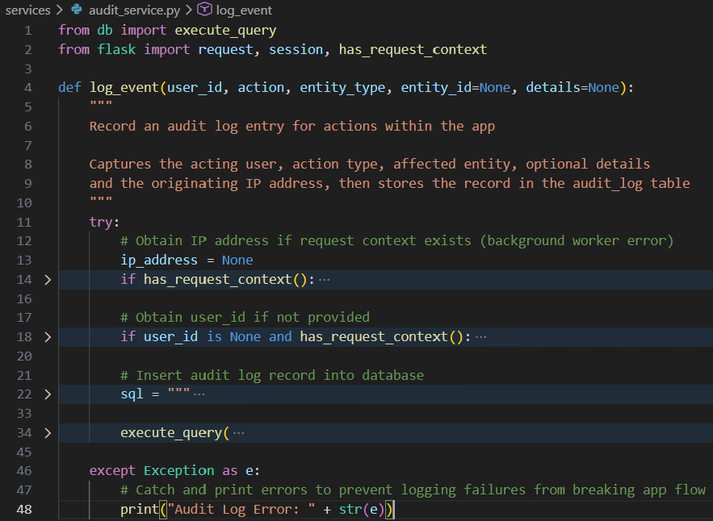
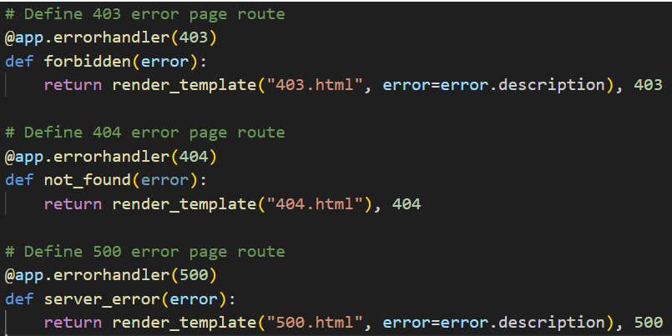
Figure C11 – Error 403, 404 & 500 page routes

Figure C12 – Overview of log_event() function

Appendix D – Scanner Integration Evidence

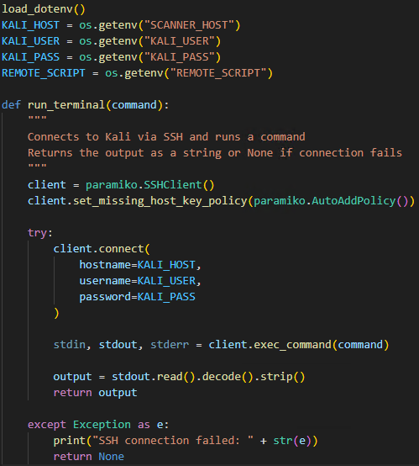
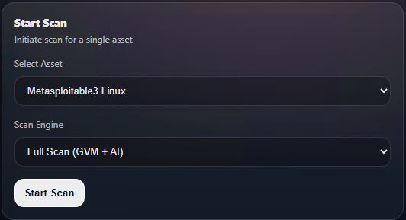
Figure D1 – Frontend Start Scan Form

Figure D2 – run_terminal() Function
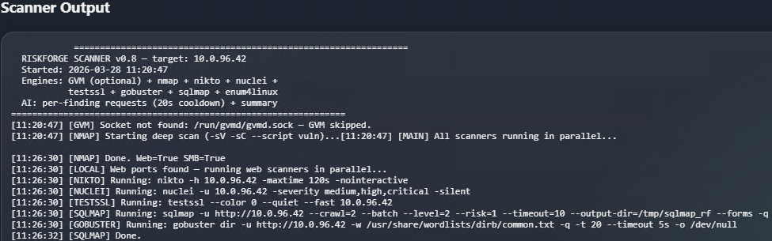
Figure D3 – Raw Scanner Output
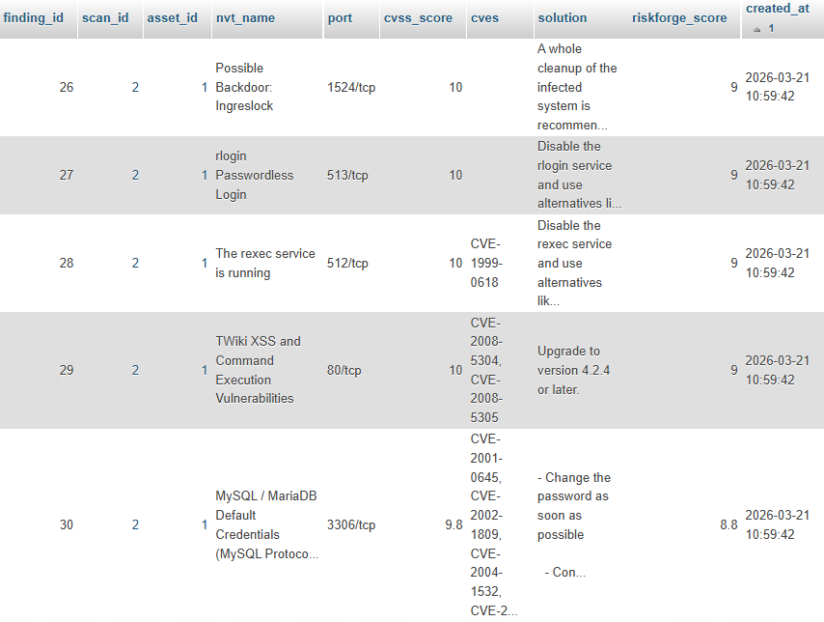
Figure D4 – Stored vulnerability findings with RiskForge scores within the database

Appendix E – AI Integration Evidence
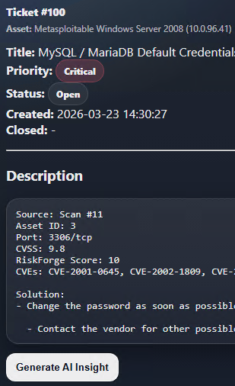
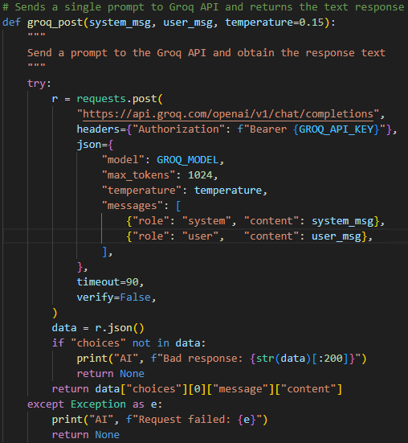
Figure E1 – groq_post() Python Function Figure E2 – Generate AI Insight Button
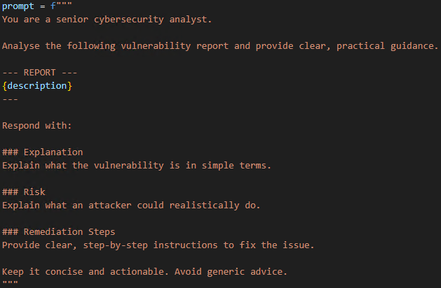
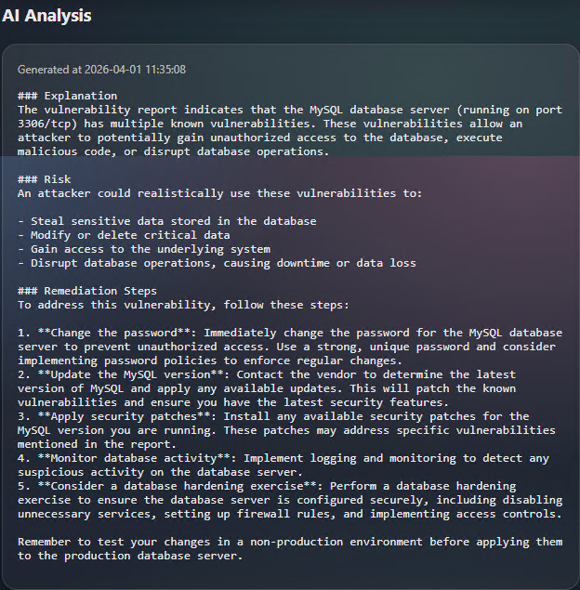

Figure E4 – Prompt Figure E4 - Prompt used within generate_ai() func

Figure E3 – Ticket AI Analysis Sample

